Singular Value Decomposition(SVD) is one of the most widely used Unsupervised learning algorithms, that is at the center of many recommendation and Dimensionality reduction systems that are the core of global companies such as Google, Netflix, Facebook, Youtube, and others.
According to the formula for SVD,
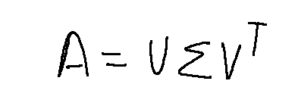
SVD Formula
- A is the input matrix
- U are the left singular vectors,
- sigma are the diagonal/eigenvalues
- V are the right singular vectors.
The shape of these three matrices will be
- A — m x n matrix
- U — m x k matrix
- Sigma — k x k matrix
- V — n x k matrix

Step 1
So, as the first step, we need to find eigenvalues (watch the video provided below to get an understanding of eigenvalues and eigenvectors) of matrix A and as A can be a rectangular matrix, we need to convert it to a square matrix by multiplying A with its transpose. Here, for easier computation I have taken A as a 2 x 2 matrix.
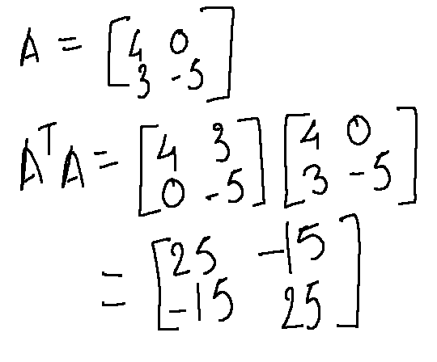

Step 2
Now, that we have a square matrix, we can calculate the eigenvalues of A(transpose) A. We, can do so by calculating the determinant of A(transpose)A — (lambda)I where lambda are the two eigenvalues.
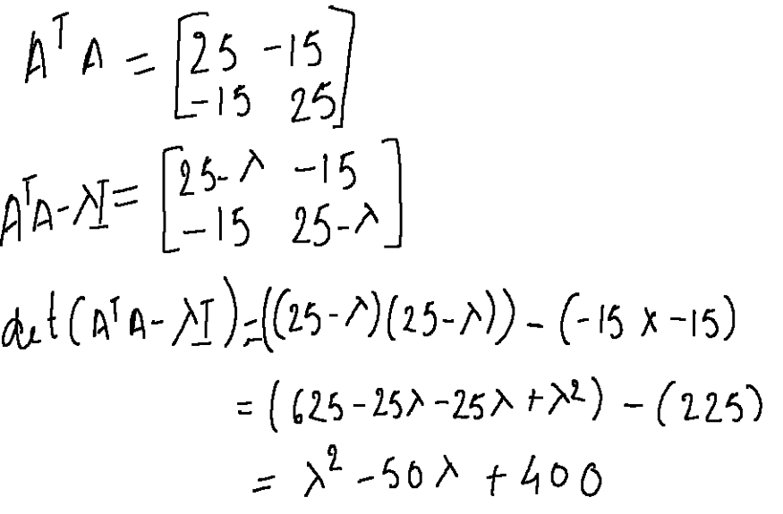
Solving the equation, we get
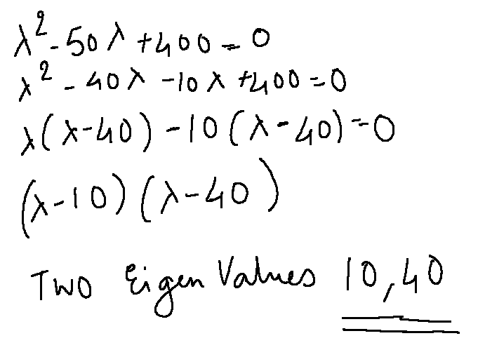
Eigenvalues

Step 3
Once we have calculated the eigenvalues, it’s time to calculate the two eigenvectors for each eigenvalue. So, let’s start by calculating the eigenvector for 10.
Step 3.1
We plug the value of lambda in the A(transpose)A — (lambda)I matrix.
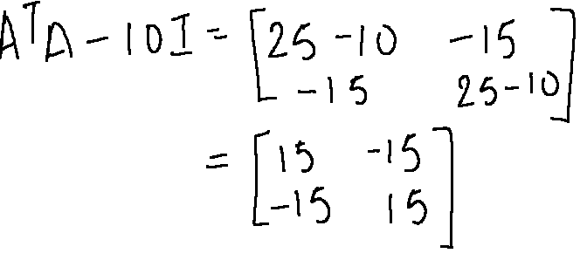
In order to find the eigenvector, we need to find the null space of a matrix where AB = 0. In other words,
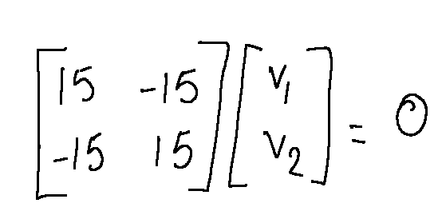
Null Space Formula
Next, we need to reduce this matrix to the Row-Echelon Form so that we can easily solve the equation. Let’s talk about Row-Echelon for a moment here.
Row-Echelon Form
A matrix is said to be in row-echelon form if the following rules are satisfied.
- All the leading entries in each row of the matrix is 1
- If a column contains a leading entry then all the entries below the leading entry should be zero
- If any two consecutive non-zero rows, the leading entry in the upper row should occur to the left of the leading entry in the lower row.
- All rows which consist only of zeros should occur in the bottom of the matrix
We need to perform some operations on the rows to reduce the matrix. These operations are called elementary row operations and there are a certain rules to follow for these operations as given below,
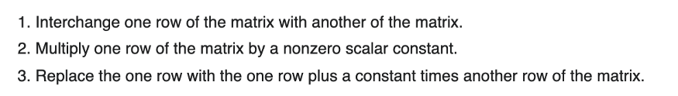
Armed with the above rules, lets start reducing the matrix in Step 3.1 to row-echelon form.
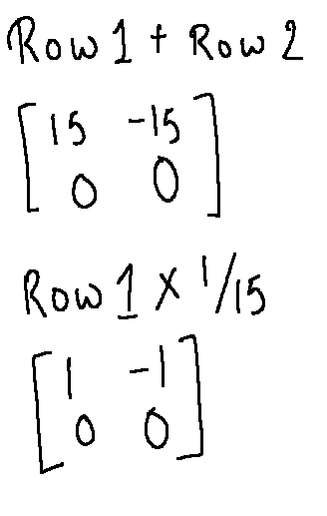
Row-Echelon Form for matrix mentioned in Step 3.1
Now, we can solve for null space as below to find the eigenvector for eigenvalue 10
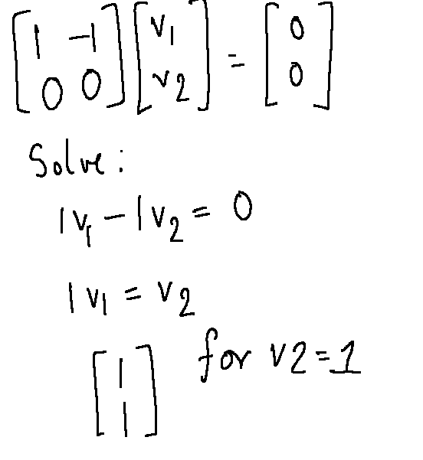
Once we get this vector, we need to convert it to a unit vector. The way we do that is by taking the columnar values and dividing them by taking the square root of the sum of squares of the values. So, in this case we do the following,
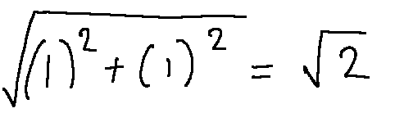
Denominator
So the final eigenvector for eigenvalue is
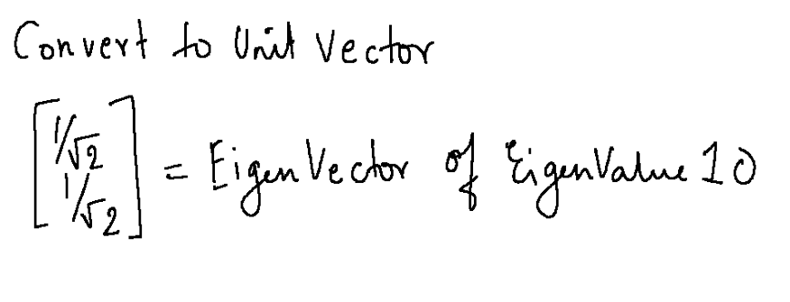
3i + 2j + 1k = 3/sqrt14 I +
We do the similar steps to get the eigenvector for eigenvalue 40
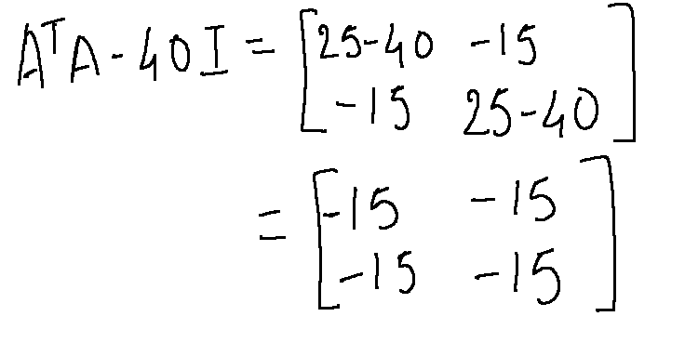
Matrix for computation
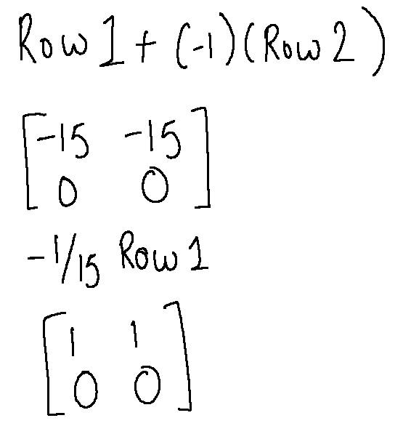
Row-Echelon Form
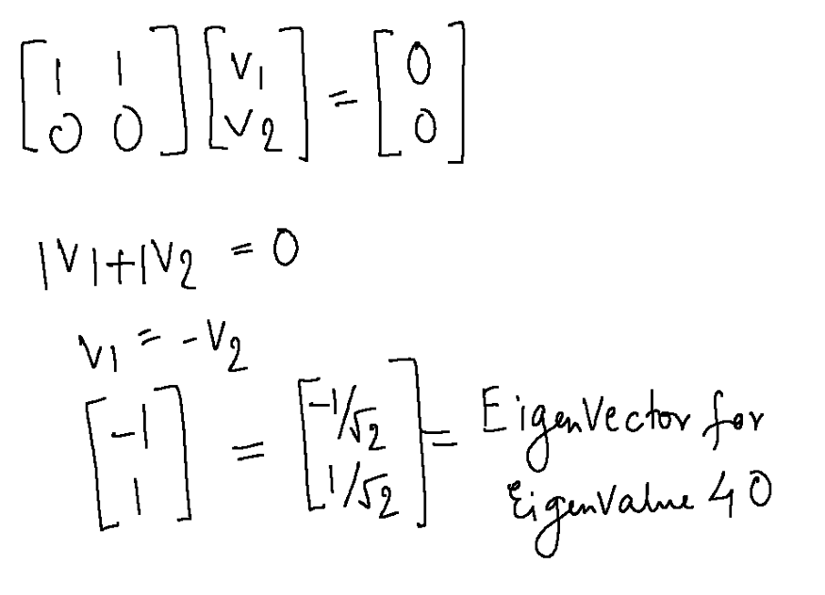
EigenVector for 40
Now that we have got both the eigenvectors, let’s put it together.
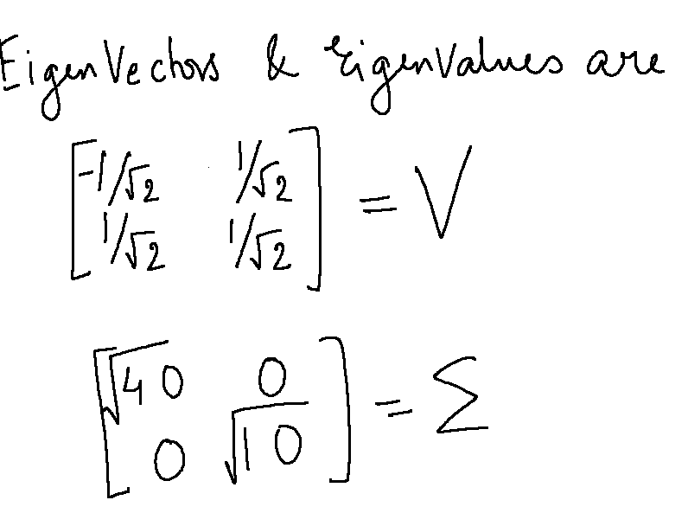
Note that the diagonal values in sigma are always in the descending order and so the vectors are also placed in that corresponding order. If you are familiar with PCA, the principal components correspond to the top k diagonal element which captures the most variance. The higher the value, the more important the component is and the more variance they describe.

Step 4
Now that we have our V and Sigma matrices, now it’s time to find U. We can just multiply the equation by sigma(inverse) and V on both sides to get the equation for U. In this case, as V is an orthogonal matrix, the transpose and inverse of V are the same, therefore, V(transpose) multiplied by V becomes an identity matrix.
Note: On the left hand side, it is sigma(inverse) and not transpose as mentioned in the slide below
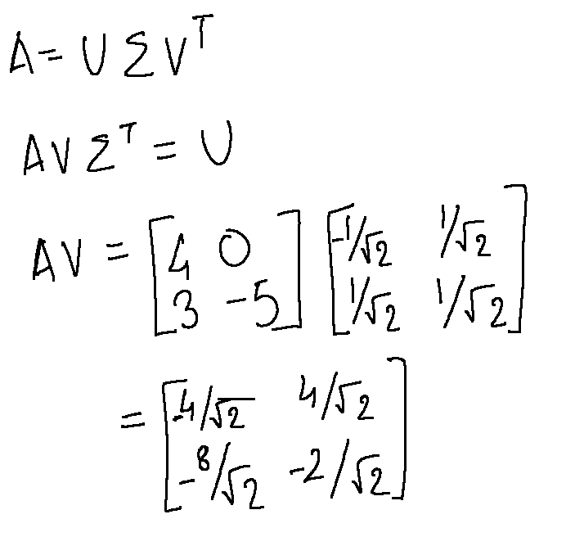
Computing A x V
Next up, we need to convert this to unit vectors using the steps described above.
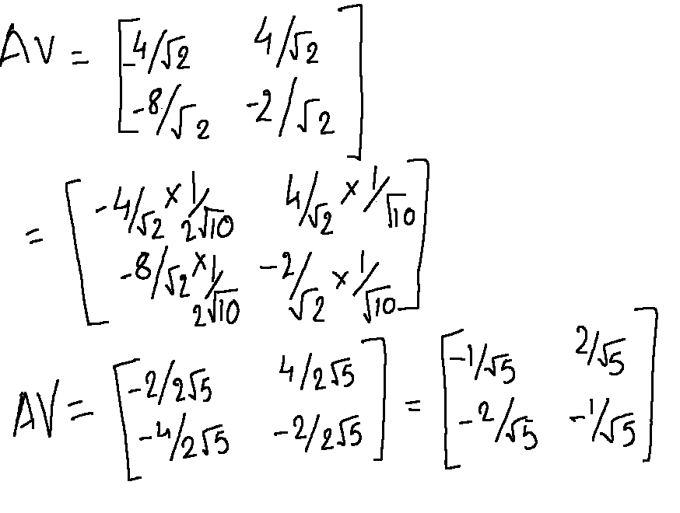
AV as unit vectors
Next up we multiply this matrix with Sigma (transpose) which is sigma in itself because its a diagonal matrix.
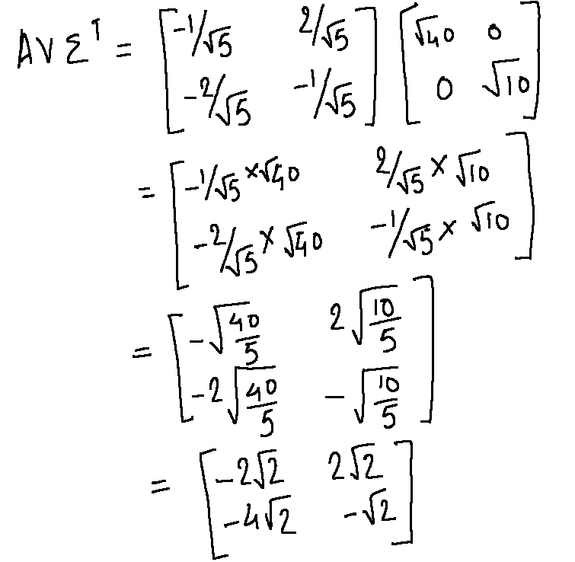
AV x sigma (transpose)
Now, we need to convert this to unit vectors to get the final U matrix.
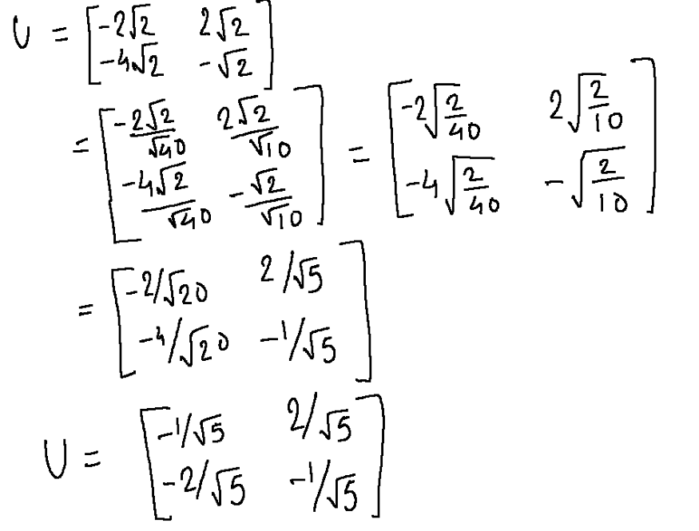
U
So, there you go, we have calculated U, sigma and V and decomposed the matrix A into three matrices as given below.
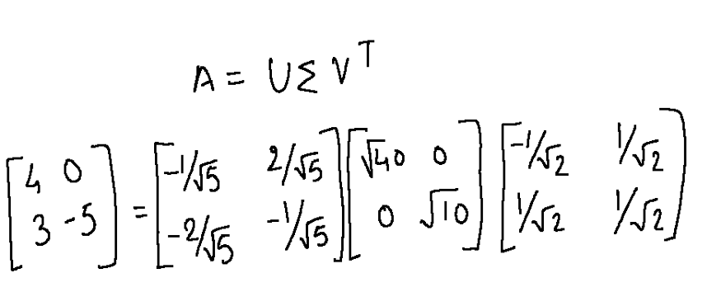

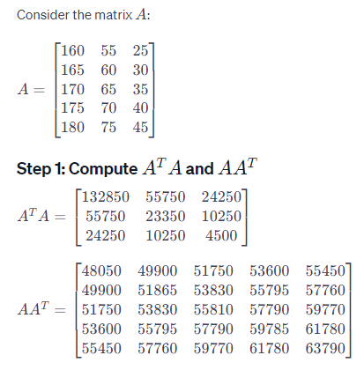
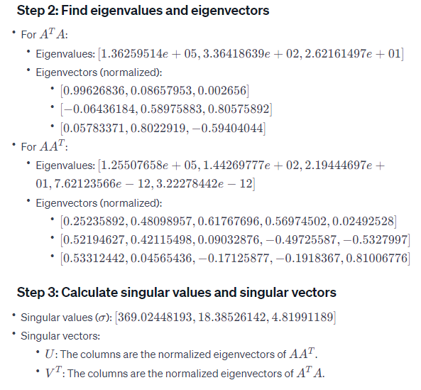
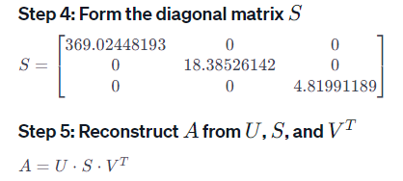

**Advantages of Singular Value Decomposition (SVD):**
1. **Dimensionality Reduction:** SVD is often used for dimensionality reduction, which can be beneficial in various applications. It allows you to represent a matrix with a reduced set of singular values and vectors, capturing the essential information in the data.
2. **Data Compression:** SVD can be used for data compression, especially in image and signal processing. By retaining only the most significant singular values and vectors, you can represent data with reduced storage requirements.
3. **Noise Reduction:** SVD can help in separating signal from noise. By focusing on the dominant singular values and vectors, you can filter out noise and retain the underlying patterns in the data.
4. **Collaborative Filtering in Recommender Systems:** SVD is widely used in recommender systems to make predictions about a user's preferences based on the preferences of other users. It helps uncover latent features in user-item interaction matrices.
5. **Pseudoinverse Calculation:** SVD provides a way to calculate the pseudoinverse of a matrix, which is useful in solving linear least squares problems when a matrix is not square or invertible.
6. **Numerical Stability:** SVD is a numerically stable method for solving linear systems and is less prone to computational errors compared to other methods.
**Disadvantages of Singular Value Decomposition (SVD):**
1. **Computational Complexity:** SVD can be computationally expensive, especially for large matrices. The time complexity is cubic in the size of the matrix, making it less efficient for very large datasets.

2. **Memory Requirements:** SVD may require significant memory, especially for large matrices, which can be a limitation in memory-constrained environments.
3. **Interpretability:** The interpretation of the singular values and vectors might not be straightforward, particularly when dealing with high-dimensional data. It can be challenging to interpret the meaning of the latent features.
4. **Not Robust to Outliers:** SVD is sensitive to outliers in the data. A single outlier can significantly impact the decomposition, potentially leading to less accurate results.
5. **Loss of Information:** In dimensionality reduction, the process of retaining only a subset of singular values and vectors results in a loss of information. The challenge is to determine the appropriate number of components to retain.
6. **Applicability to Sparse Data:** SVD is more challenging to apply directly to sparse matrices. Techniques like Truncated SVD are often used to address this issue.
Regular Inverse of a Square Matrix
Inversion a Matrix means a process to create a reciprocal version of a Matrix.
In math, the reciprocal of a number means inverse of a number, for example, we have a number called b, inverse of b number can be written as b-1 . b-1 comes from: 1/b (reciprocal of b). Meanwhile for a matrix, e.g matrix A, inverse of A matrix can be written as A-1
In order to be inverted, a matrix must meet 2 conditions :
- the matrix has the same number of rows and columns (square matrix)
- determinant of the matrix is not zero.
The Pseudo Inverse of a Matrix
The Pseudo inverse matrix is symbolized as A dagger.
However, sometimes there are some matrices that do not meet those 2 requirements, thus cannot be inverted. Where the condition is overdetermined, we can use a method called pseudo inversing to create a pseudo inverse matrix version of our original matrix.
We are going to use SVD (Singular Value Decomposition) Trick to decompose a non square matrix which doesn’t have eigenvalue and eigenvector.
Inversing an Invertible Square Matrix
Inversing a square matrix is easy. For example, We have A matrix:
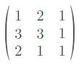
In order to get inverse of A, we are going to use adjoint method :
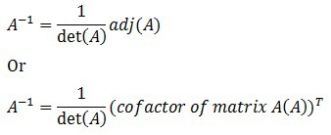
Inverse of A can be acquired from these steps:
- Step 1. calculating determinant of A
- Step 2. find cofactor of A
- Step 3. find adjoint of A
- Step 4. find the inverse
determinant of our matrix = -6.
So we can go straight ahead to step 2 : “find cofactor of A”.
First of all, we need to get minor of A. Minor of A can be obtained by getting 2x2 possible matrix determinants of A :
Visually, we can do the trick a lot easier:
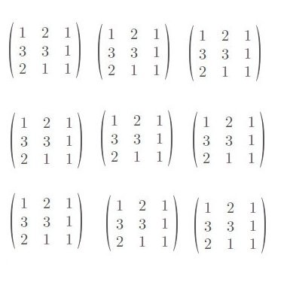
Next:
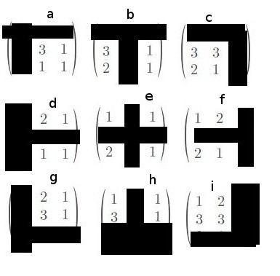
hence we got :
|a| = 2 , |b| = 1 , |c| = -3, |d| = 2, |e| = -1, |f| = -3, |g| = -1, |h| = -2 , |i|= -3
Thus we got minor matrix:
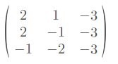
Cofactor matrix can be obtained easily:
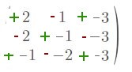
Hence we got cofactor matrix:
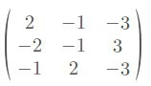
Step 3, find adjoint of A :
Adjoint can be obtained by transforming cofactor matrix columns into rows, Adjoint :
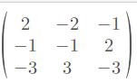
Finally based on our formula:
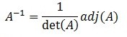
A-1 = 1/-6 * adjoint matrix, Hence we got our inverse matrix :
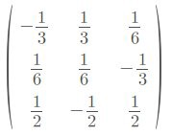
Pseudo Inverse Matrix using SVD
Sometimes, we found a matrix that doesn’t meet our previous requirements (doesn’t have exact inverse), such matrix doesn’t have eigenvector and eigenvalue. In order to find pseudo inverse matrix, we are going to use SVD (Singular Value Decomposition) method.
For Example, Pseudo inverse of matrix A is symbolized as A+
When the matrix is a square matrix :
A+ = A-1
when the matrix is overdetermined:
A+ = VΣ-1 Ut
V, Σ and U are matrices from SVD of A.
Where SVD of A :
UΣVt
can be notated :
UsVt
or
USVt
or

UDVt
Example of Pseudo Inverse Calculation using SVD Method
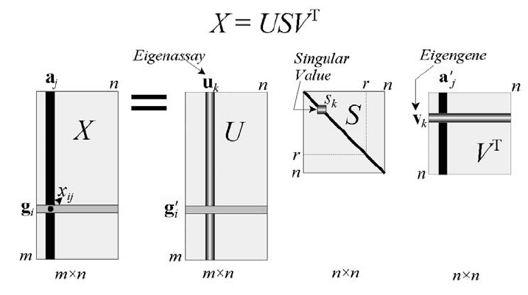

Derivation of Pseudo-inverse
Note: Skip the derivation and use the final result only if getting maths heavy.
To estimate the solution of pseudo-inverse, Singular Value Decomposition (economy variant) comes into the picture. We know that Economy SVD is

We know that the system of equation is
2x1 + 3x2 = 6
3x1 + 4x2 = 8

Replace A with the economy variant SVD
Multiply both sides by the following equation
Our equation will become:

We can re-write the above equation as

which is called Moore-Penrose Inverse or Pseudoinverse.

Manual Example of Estimating Pseudo-inverse
Let’s say we have the following matrix of 4 X 2 in size and we want to compute its pseudo-inverse.
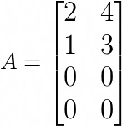
Our current objective is to find the pseudo-inverse because that’s what we want. Our decomposition matrices are:
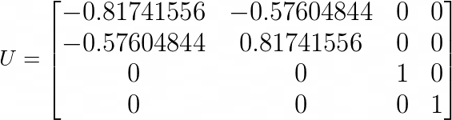
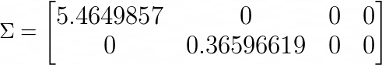
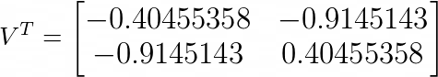
What’s left? just using the derived formula and getting the pseudo-inverse of the matrix A. Now transposing a matrix is simple, but taking the inverse is not. So, if you don’t know how to take the inverse of a matrix, not a problem. Once we find the inverse of the matrix and transpose the U and V matrices, we can proceed with estimating the pseudo-inverse.
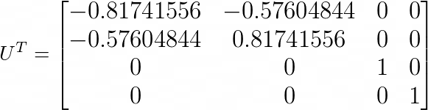
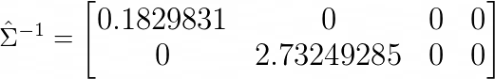
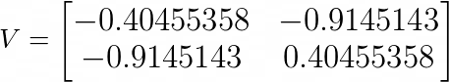
Using the Moore-Penrose inverse equation:
We get pseudo-inverse, which is exactly what we want. Easy, right?
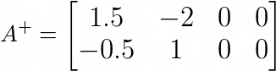

**Linear Discriminant Analysis (LDA): Introduction**

Linear Discriminant Analysis (LDA) is a technique used in statistics, pattern recognition, and machine learning for dimensionality reduction and classification. It's primarily used as a supervised classification algorithm, where the goal is to find the best linear combination of features to separate different classes in the data.

LDA seeks to maximize the separability between classes while minimizing the variance within each class. It achieves this by projecting the data onto a lower-dimensional subspace while maintaining the class discrimination.

**Linear Discriminant Analysis (LDA): Mathematics**

Given a dataset with \(n\) samples and \(m\) features, and \(c\) classes, let's define some terms:

- \(X_i\) is the \(i\)th class in the dataset.
- \(N_i\) is the number of samples in \(X_i\).
- \(\mathbf{X}_i\) is the matrix of samples in \(X_i\).
- \(\mathbf{m}_i\) is the mean vector of \(X_i\).
- \(\mathbf{m}\) is the overall mean vector.

**Key steps in LDA:**

1. **Compute Class Means:**
- Calculate the mean vector for each class: \(\mathbf{m}_i = \frac{1}{N_i} \sum_{\mathbf{x} \in X_i} \mathbf{x}\).

2. **Compute Scatter Matrices:**
- Within-Class Scatter Matrix (\(S_W\)):
\[S_W = \sum_{i=1}^{c} \sum_{\mathbf{x} \in X_i} (\mathbf{x} - \mathbf{m}_i)(\mathbf{x} - \mathbf{m}_i)^T\]
- Between-Class Scatter Matrix (\(S_B\)):
\[S_B = \sum_{i=1}^{c} N_i (\mathbf{m}_i - \mathbf{m})(\mathbf{m}_i - \mathbf{m})^T\]

3. **Compute Eigenvalues and Eigenvectors:**
- Solve the generalized eigenvalue problem \(S_W^{-1}S_B\) to obtain the discriminant vectors (\(W\)).

4. **Projection:**
- Project the data onto the discriminant vectors: \(\mathbf{Y} = \mathbf{W}^T \mathbf{X}\).

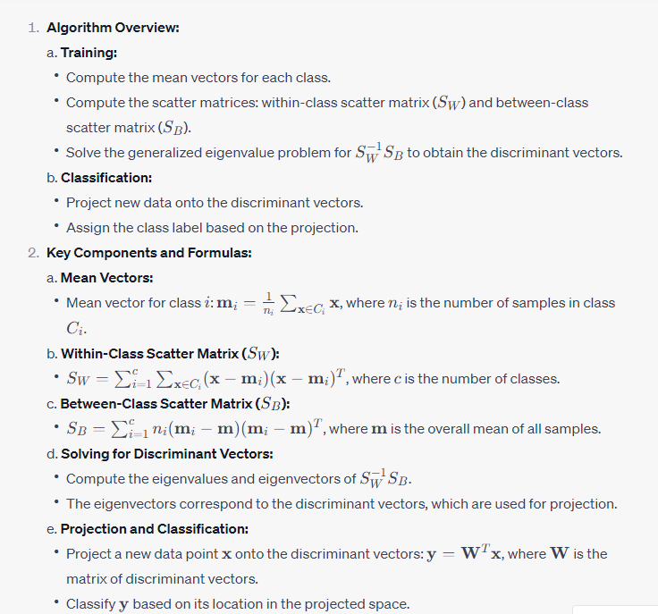

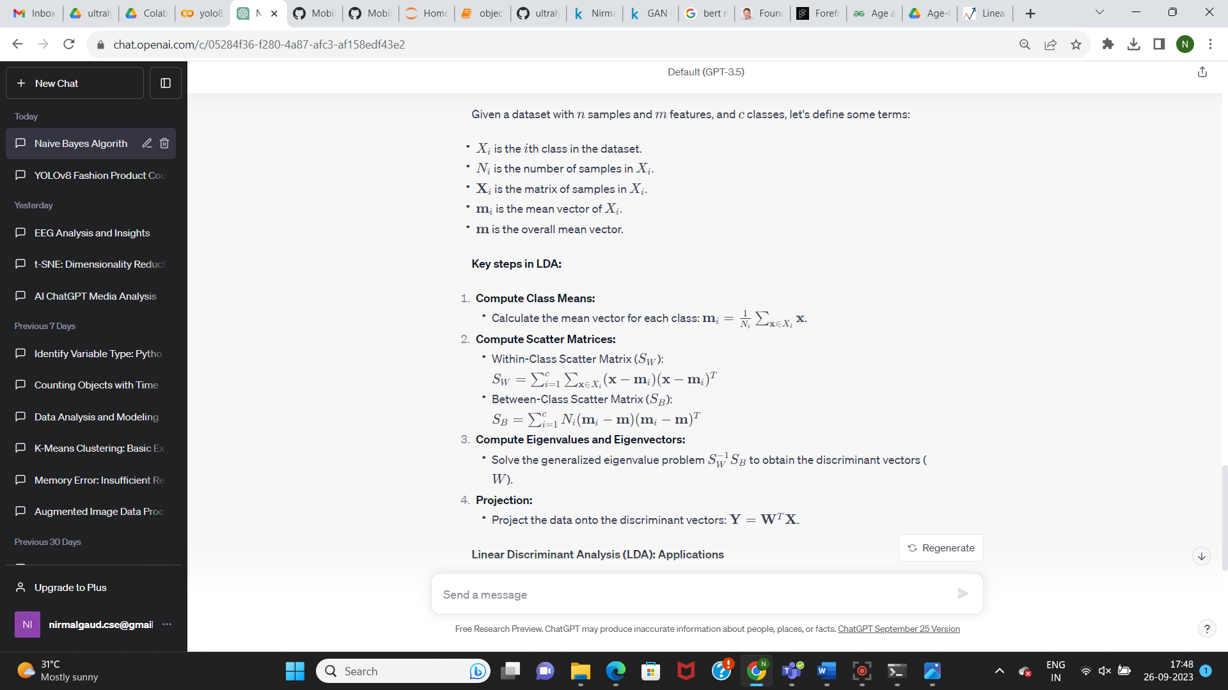
**Linear Discriminant Analysis (LDA): Applications**

1. **Pattern Recognition and Classification:**
- LDA is used for classification tasks, especially when there are multiple classes involved and the goal is to reduce the feature space while maintaining class discrimination.

2. **Dimensionality Reduction:**
- LDA is used to reduce the dimensionality of the feature space while retaining most of the relevant information for classification.

3. **Face Recognition:**
- In facial recognition systems, LDA can help extract discriminant features from images to improve classification accuracy.

4. **Biometrics:**
- LDA is used in various biometric applications, such as fingerprint and hand geometry recognition, to improve accuracy and efficiency.

5. **Natural Language Processing (NLP):**
- In text classification tasks, LDA can be used to identify key topics or themes in a corpus of documents, aiding in categorization or clustering of text data.

LDA is a versatile technique with applications in various domains where classification and dimensionality reduction are crucial tasks.

